
Vector Review
Table of Contents
Overview 2
What is a Vector? 2
Vector Tool Box 3
Add 3
Subtract 4
Scalar Multiply 5
Dot Product 6
Cross Product 11
Magnitude 13
Normalize 13
Conclusions 14
Review Question 14

Overview
Hopefully you are already familiar with vectors. When I say a vector, I am referring to the mathematical vector, not the std::vector class, though that is a good thing to be familiar with too. In a perfect world vector review day would be a complete review on a subject matter that you already know inside and out. I’m hoping that this is all very boring because you already understand vectors really well, but I understand that this may not be exactly the case.
It is the goal of this paper and the similar lecture to provide a review of vectors and all their operations that we will need in order to perform the tasks required for future class assignments. A secondary goal is to provide a direct application for each vector operation.
We will be putting together a vector “tool box.” This tool box will contain all of the vector operations we should need, no more, no less, at least for ED1.

What is a vector?
In 3D we typically represent a vector like this (x, y, z), where each component represents a distance in that cardinal direction.
Vectors have two parts, a direction and a magnitude. Notice I did not say they have a position, because they do not. Technically, all vectors are placed at the origin but we will often see them drawn elsewhere. Just because a vector is drawn away from the origin does not mean it has a position. The vector (2, 1, 0) is the same no matter where I think about it existing at, because its direction and length do not change.
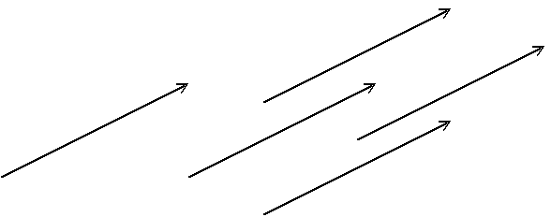
These are all the same vector, (2, 1, 0).
So let’s break down what a vector does have starting with a magnitude. Magnitude just refers to the relative size of something. In the case of a vector we can think of this as being the length of the vector and we can represent it as a scalar value. The Magnitude of the vector (5, 0, 0) is 5. Most vectors’ magnitudes will be more difficult to find, we will cover how we get the magnitude of a vector later.
Now we need to discuss the direction part of a vector. We can think of the direction as being the orientation of the vector, represented by a scalar amount in our cardinal directions, x, y, and z. Well that kind of sounds like we just defined the direction part of a vector as being a vector, and we did. We have to define the direction part as a special type of vector, whose magnitude is always 1. A vector with a magnitude of 1 can be referred to as a unit vector, a normalized vector or a direction vector. In the case of the vector (5, 0, 0), the direction of this vector can be represented as the unit vector (1, 0, 0), this vector points in the same direction, but its magnitude is 1.
So vectors have direction and magnitude, but no position. What if we want to represent a point in space though, can’t we use a vector for that? The answer is yes, but remember that if we treat a point in space like a vector, it is a vector pointing from the origin to the point.
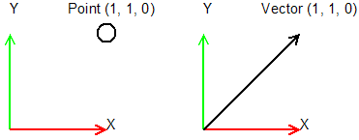

Vector Tool Box
To make life easier for me, and you, consider all upper case single characters to represent a vector, and lower case single characters to represent a scalar value, ex :
A is a vector like (.707, .707, 0)
s is a scalar value like 5

Add
Probably the simplest tool we will need in our vector tool box is the ability to add vectors together. Here is what the math looks like for that.
C = A + B
C.x = A.x + B.x
C.y = A.y + B.y
C.z = A.z + B.z
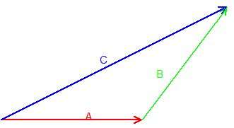
C = A + B or
C = B + A both are true.
A very common application for vector addition is when we need to move something in 3D space. We have a vector representing position and one representing velocity, to move we add velocity to position.

Subtract
If we can add vectors we should be able to subtract them too.
C = A – B
C.x = A.x - B.x
C.y = A.y - B.y
C.z = A.z - B.z
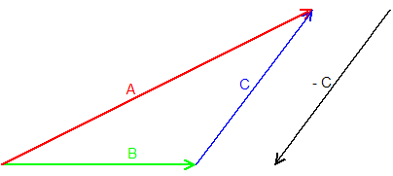
C = A – B
but C does not B – A, although
-C = B – A
A good way to remember which way the resulting vector is pointing is that it will always point at what you are subtracting from. In the case of C, we are subtracting from A so it points at A.
A common use for vector subtraction is to get the vector between two points. This can be used to find how to face a target, or with the help of a magnitude method, to get the distance to a target.

Scalar Multiply
There are three different types of vector multiplies we will cover, first being a scalar multiply. To perform a scalar multiply we need a vector and a scalar value to multiply this vector by. The result of a scalar multiply is the same vector, with only its magnitude changed.
A’ = A(s)
A’.x = A.x * s
A’.y = A.y * s
A’.z = A.z * s
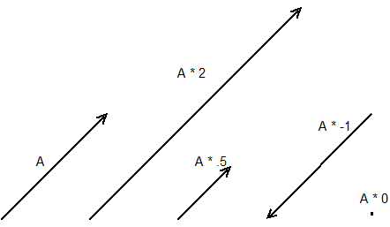
In all of these cases except A * 0 we are just changing the magnitude and leaving the direction alone. Even in the case of A * -1 we can say that the vector points in the same direction as A, it just now has a negative magnitude. Whether you consider this result to have set the magnitude negative or flipped the direction is really up to your application. Also in all of these cases we can get the original vector back by scaling by the inverse of what we scaled by the first time. If A’ = A * 2 then A = A’ * ½.
When we scale by 0 we have a special case. No matter what the original vector is, after we scale by 0 it will be (0, 0, 0), probably not what was intended.
A common action that will require scaling a vector is movement. We may have a direction to move in and a speed to move by. To get a velocity we scale our direction vector by our speed. This is also a common place to make the possible mistake of scaling by 0, if our character is not currently moving then our speed should be 0. This is something to watch for. It probably will not cause an issue with the movement, but if the velocity is (0, 0, 0) and other vector operations are performed on this you may get undefined results.

Dot Product
The dot product is our bread and butter. We will use this operation to solve so many things in this class it will be a little silly. Here is the math for the dot product of two 3D vectors.
s = A dot B
s = A.x * B.x + A.y * B.y + A.z * B.z
Notice the result is a scalar value. The algorithm for a dot product is to multiply like components, such as x, y, z, and add the results. This can be extended to sets of data greater in length than our 3D vectors. You will often see the formula in text books given like this,
s = U dot V
s = U.1 * V.1 + U.2 * V.2 +…+ U. ∞ * V.∞

This just shows that the number of components does not matter, as long as both U and V have the same amount of components.

So, what does the dot product tell us and why do we care so much? Let’s start by thinking about what the dot product gives us on unit length vectors.
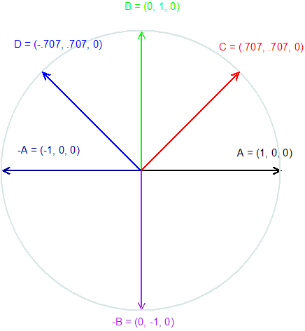
A dot A = 1, A dot B = 0, A dot –A = -1, A dot –B = 0, A dot C = .707 and A dot D = -.707
From these results we should see that the angle between the vectors being dotted changes the results. We can extrapolate that if the angle between two vectors is less than 90 degrees the result of the dot product will be positive, otherwise it will be negative. This is a very important idea. We can think that as the angle between vectors decreases, the dot product increases.

This relationship to the angle is so important, that we actually use it to find the angle between two vectors. The formula to find the angle between two vectors follows,
Angle = ACos ( (A dot B) / (A.Magnitude() * B.Magnitude()) )
Finding the angle between two vectors seems like a useful thing to know at first but we will find that anytime we think we care about the angle all we really need is the dot product, and it will tell us enough about the relationship to do what we need. In fact, in this class the only time we will find the angle between two vectors is if we want to show it to the user.

You will notice in the angle formula above, we divided the result of the dot product by the product of the two vectors lengths. This was to remove any effect the magnitude of the vectors had on the result. So what happens to the result of a dot product if we leave magnitude in, what if one of the vectors is not normalized? Let’s think about a few examples.
A = (1, 0, 0)
B = (2, 1, 0)
A dot B = 2 (2 * 1 + 1 * 0 + 0 * 0)

B = (2, 10, 0)
A dot B = 2 (2 * 1 + 10 * 0 + 0 * 0)

B = (2, ¶, 42.42)
A dot B = 2 (2 * 1 + ¶ * 0 + 42.42 * 0)
We see that since the y and z components of A are both 0, the y and z components of B will not be factored into our result, but this is hiding what is really happening. What we are really getting is B’s length in the direction of A.
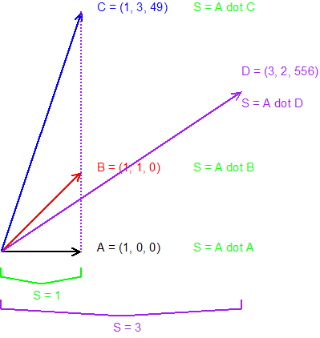
This is the key to seeing what the dot product is really giving us as a result. We can always think of the resulting scalar as being the projected distance of one of the vectors being projected onto the other, the order does not matter.

So what can we do with this? Lets imagine we were making an asteroids game and we wanted to write AI to fly our ship. At some point we would need to decide, do we rotate right or left to aim at an asteroid.
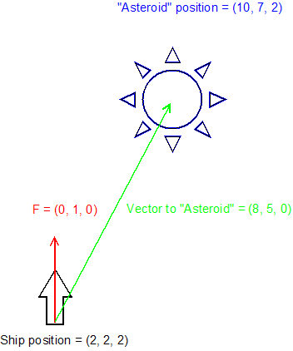
The vector to the asteroid from the ship is found by subtracting the ships position from the asteroids position. We can see that the ship needs to turn right before it can shoot the asteroid, but how can we make our computer know that? We might be tempted to do something like this,
int s = dot_product(F, VectorToAsteroid);
if(s > 0)
rotate right;
else
rotate left;
This will work for our current set up, but it does not quite work out in all cases, as shown below.
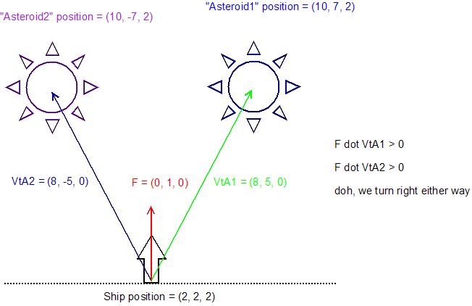

We should see that anything above the dotted line will give us a positive result. What we really need is a “Right” vector not a “Forward” vector (F) like we have. Well, we will learn how to find perpendicular vectors shortly, but for now let’s assume we are in 2D and use a trick. In 2D a Right vector R = (F.y, -F.x). With this vector we can get the result we want.
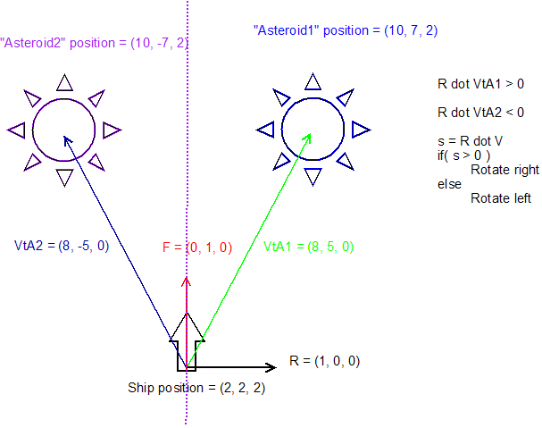
This test is called the 3D half-space test. Its applications are immeasurable. We can think of the dotted line as representing a plane in space. If s > 0 then we are in front of this plane, otherwise we are behind it. The way we are using this formula currently, abs(s) is actually the distance to the plane. We will cover planes further another day.
Remember when we dot two vectors; if the angle is less than 90 degrees, the result is positive, if the angle is greater than 90 degrees the result is negative.
Here is one more example that does not directly deal with gaming. Imagine you were taking a class, and your grade in this class was based on 13 assignments, each worth various percentages. We could make a normalized vector from this data that would look like this,
(0.05, 0.05, 0.05, 0.2, 0.02, 0.04, 0.04, 0.1, 0.1, 0.05, 0.1, 0.1, 0.1)
We could make a second vector based on your grade percentage for each of these, like this,
(100, 100, 100, 100, 100, 100, 100, 100, 100, 100, 100, 100, 100)
We can then dot these two vectors to find your grade.

Cross Product
The cross product formula is typically used to find a vector that is perpendicular to two given vectors. There is an infinite set of perpendicular vectors to any one given vector. There are only two perpendicular vectors to two different vectors. So, when we use the cross product, which of the two perpendiculars do we get? This depends on how we write the formula and whether our coordinate system is right or left-handed. Here is how the right and left-handed thing works. Hold up both hands. Make two fists. Uncurl your thumbs, and point them in the direction you want X to be. Next uncurl your index fingers, and turn your hands so your index fingers are pointing where you want Y to be. Stop turning your hands. Now uncurl your middle finger, this is the direction Z points in relation to X and Y, in a right or left handed system. If you pointed X to the right and Y up, then on the right-handed system, Z will point at you, and on the left-handed one it will point away. For ED1 we will be using the right-handed coordinate system. Now let’s talk about the math.
C = A cross B
The formula for cross product can be hard to remember. If you already remember it a certain way, keep using that, if not here is the way I think is easiest to remember it.
The first thing we need to find is C.x.
C.x = A.y * B.z – some other stuff
Look at that pattern. The components we are interested in go, x, y, then z. We will get back to the “some other stuff” later. Next we need C.y.
C.y = A.z * B.x – some other stuff
This is the same pattern, just starting at y then z, then x, same order, just starting later. Finally we need C.z.
C.z = A.x * B.y – some other stuff
Again, same pattern just starting at z. The “some other stuff” is just the opposite components on the right of the minus as on the left. So the whole formula looks like this,
C.x = A.y * B.z – A.z * B.y
C.y = A.z * B.x – A.x * B.z
C.z = A.x * B.y – A.y * B.x
When we use the cross product to find a perpendicular vector the order we cross in will be important. If A cross B gives us C, then B cross A will give us –C. In our right handed coordinate system the X axis crossed with Y will give us the Z. This X,YZ order will work to find any of the axis’, X = Y cross Z and Y = Z cross X. Another way to think about this is like the vectors being crossed are the hands of a clock. To get the vector facing out of the clock, we cross the hands in counter-clockwise order.
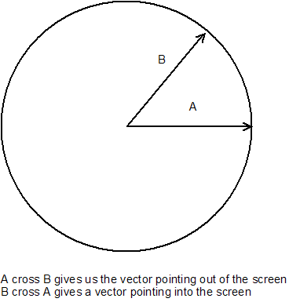
Another thing that will prove to be important to us is the length of the resulting vector when we perform a cross product. If A and B are perpendicular, and are unit length, then C will be unit length. As we change the angle between A and B or the lengths of A and B we change the length of C. Here is the definition for that property, the length of the resulting vector of A cross B is equal to the area of the parallelogram defined by A and B. That probably sounds crazy, but once you can see it, it will be easy to see this relationship, hopefully.
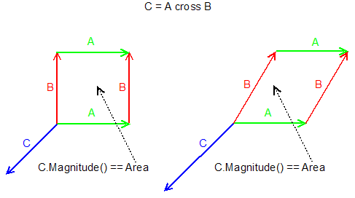
If in either of these examples I made A or B longer, then C would get longer. As the angle between A and B approaches 90 degrees, C gets longer.
This relationship has a good use for us, as we will see in another asteroid example. Imagine we have a large asteroid that will not explode when we shoot it and a center of mass away from the center of the asteroid. When it is shot, we want it to spin about its center of mass. When it is shot closer to the center of mass it will spin slower than when it is shot further away.
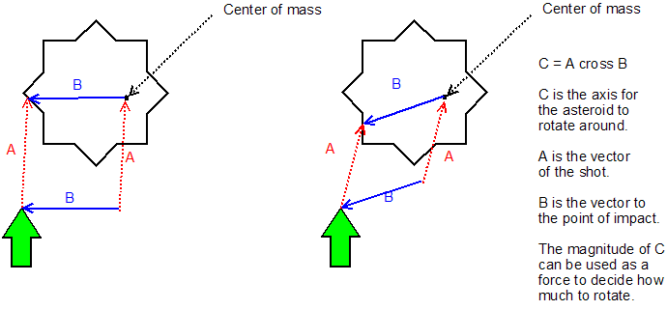

Magnitude
We need a formula to find the length of a given vector. If you can remember the distance formula, magnitude should be easy. Given two 3D points in space, we find the distance between them like this,
d = sqrt((A.x – B.x)² + (A.y – B.y)² + (A.z – B.z)²)

Now for magnitude, we want the distance from the start to the end of a vector. Remember, vectors have no position, so the start (B) is (0, 0, 0). If we are just subtracting 0, we can just remove B from the equation. So we get,

d = sqrt((A.x – 0)² + (A.y - 0)² + (A.z – 0)²)

or

d = sqrt(A.x² + A.y² + A.z²)

Normalize
The goal of the normalize function is to set a vector’s magnitude to one, making it a unit vector. To do this, we are going to scale the vector by the inverse of its magnitude.
Normalized A’ = A.norm();
d = A.Magnitude();
A’.x = A.x / d
A’.y = A.y / d
A’.z = A.z / d
We could have called our scalar multiply with the inverse of the magnitude, but we will typically write it as shown to improve readability. We will use normalize fairly often. Anytime we are building a vector from some set of data, but we are only interested in the direction of the vector, a normalize call will be required. We will use this often when we build Matrices, which we will do next class.

Conclusions
These seven vector operations are all we will typically need. The order we discussed them is the order of complexity for your computer, normalize costs more than magnitude, which should be obvious since normalize calls magnitude. For the rest the complexity cost is mostly based on how many adds and multiplies are performed. Be sure to remember the order. The dot product and formulas before it can generally be considered cheap, the cross product is not too bad but if we do too many of them, we will notice, the sqrt of the magnitude and normalize will make us want to avoid these operations where possible.
You will notice that we did not write a distance formula. If we want to find the distance between two points, we can subtract them, which make a vector, then take the magnitude of that vector. Another common thing we may need to do is find what point in a set is closest or furthest from a given point. This would require a series of costly magnitude calls, but if we had a squared distance formula, one without the sqrt in it, we could compare those squared results to find the right point. Again, we do not need to make another formula to find squared distance. To do it, subtract the points making a vector then dot that vector with itself. When you dot a vector with itself you get the vectors magnitude squared, and dot products are pretty cheap compared to a magnitude.

Review Question
A common operation that our graphics API perform for us is lighting. If we were to write our own code to do diffuse lighting, we would need to use almost our entire vector tool box. Here is the basic formula for applying diffuse lighting to a triangle.
FinalColor = Color * s
s = TriNormal dot NormalizedVectorToTheLight
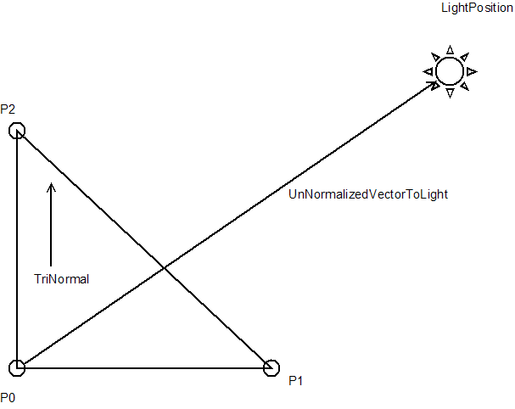
P0 = (2, 2, -2)
P1 = (4, 2, -2)
P2 = (2, 2, -4)
LightPosition = (2, 6, -5)
Color = (0.5, 1.0, 0.0)
Given these values can you find the FinalColor?

Hopefully, you got FinalColor = (0.4, 0.8, 0.0)

